SOFTWARE TESTING – TUTORIAL 1
SDLC & STLC – Automation Exercise

TC01 – Verify Login Page is Accessible
Test Case: Verify Login page is accessible
Test Data: N/A
Steps:
- Open the Automation Exercise website.
- Click on the Signup / Login option.
- Verify that the Login to your account section is displayed.
- Verify that the Email Address and Password fields are visible.
Expected Result: Login page should be displayed successfully.
Actual Result: Login page was displayed successfully.
Status: PASS
Screenshot:
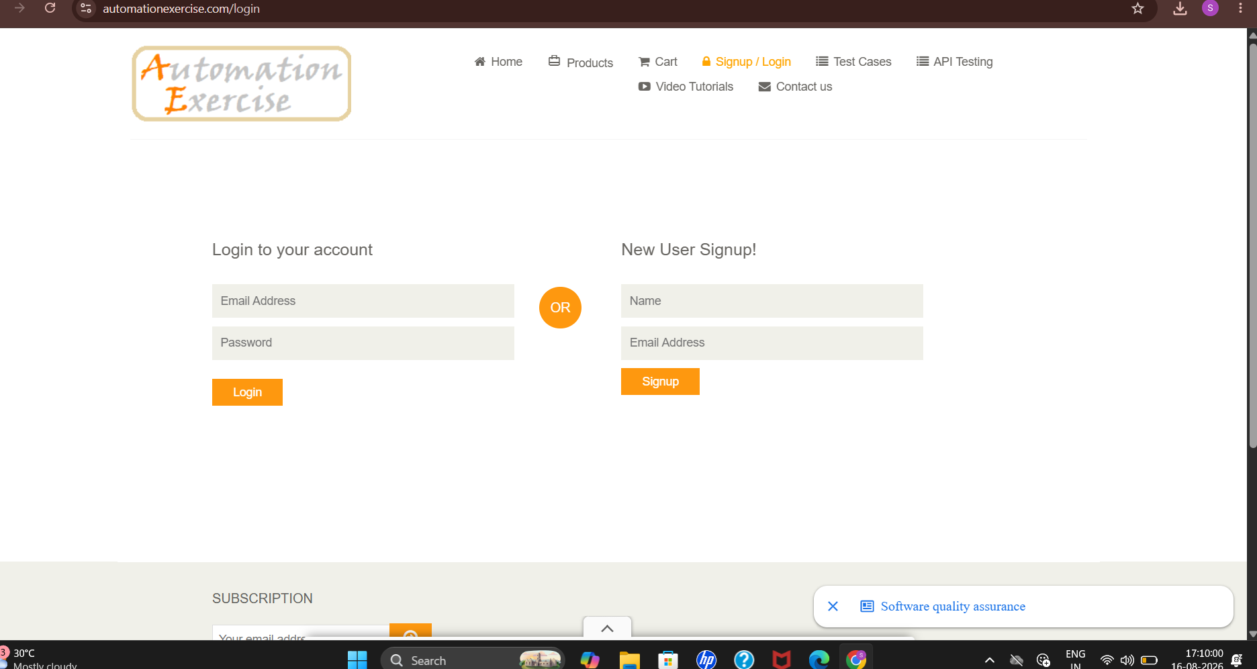

TC02 – Verify Signup Page is Accessible
Test Case: Verify Signup page is accessible
Test Data: N/A
Steps:
Test Data: Name and Email Address
Steps:
- Open the Automation Exercise website.
- Click on the Signup / Login option.
- Locate the New User Signup! section.
- Enter a valid name in the Name field.
- Enter a valid email address in the Email Address field.
- Verify that the Signup button is displayed.
Expected Result:
The Signup section should be displayed successfully with the required fields.
Actual Result:
The Signup section was displayed successfully.
Status: PASS
Screenshot:
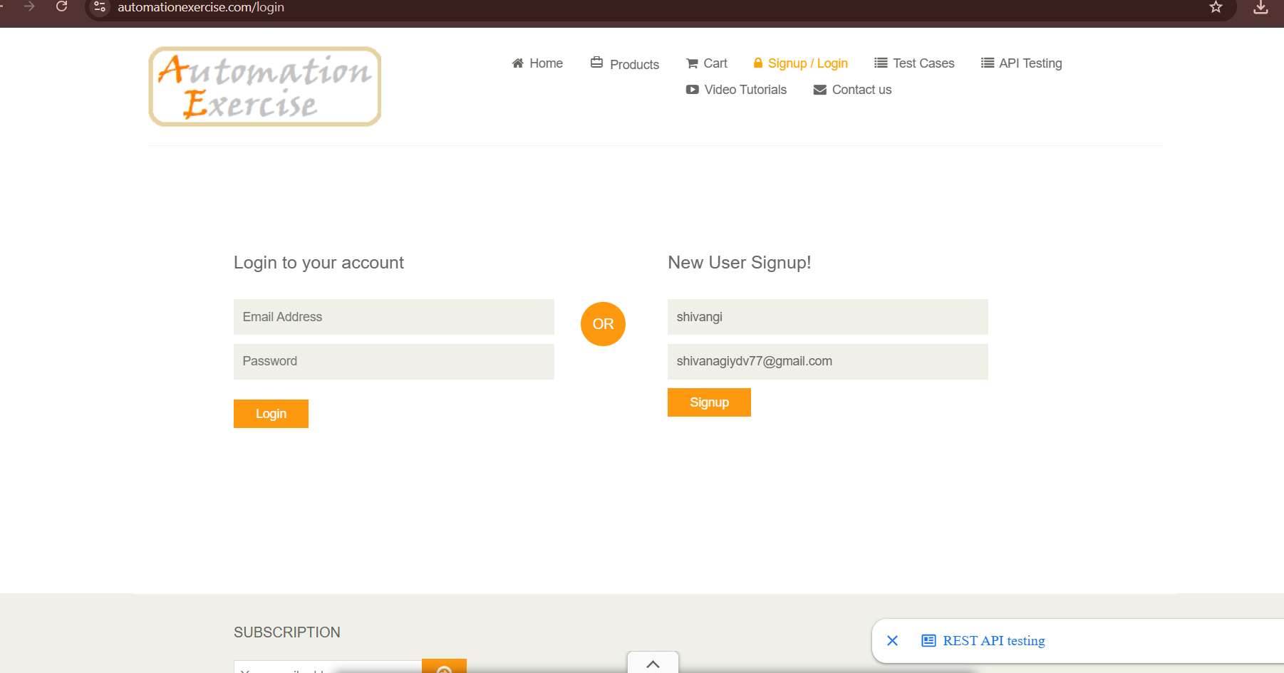

TC03 – Verify Email Field is Available
Test Case: Verify email field is available on the login page.
Test Data: N/A
Steps:
- Open the Automation Exercise website.
- Click on the Signup / Login option.
- Locate the Login to your account section.
- Verify that the Email Address field is visible.
- Verify that the Email Address field is available for entering data.

Expected Result: The Email Address field should be displayed and available for input.
Actual Result: Email field was available.
Status: PASS
Screenshot:
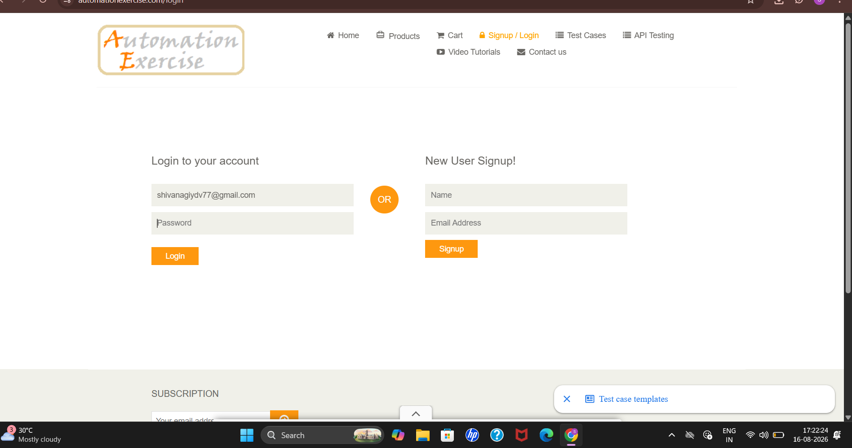

TC04 – Verify Password Field is Available
Test Case: Verify password field is available on the login page.
Test Data: N/A
Steps:
Open the Automation Exercise website.
- Click on the Signup / Login option.
- Locate the Login to your account section.
- Verify that the Password field is visible.
- Verify that the Password field is available for entering data.
Expected Result: Password field should be available.
Actual Result: Password field was available.
Status: PASS
Screenshot:

TC05 – Verify Login Functionality
Test Case: Verify that the user can log in successfully with valid credentials.
Test Data: Valid email and password
Steps:
Open the Automation Exercise website.
- Click on the Signup / Login option.
- Enter a valid email address in the Email Address field.
- Enter the valid password in the Password field.
- Click on the Login button.
- Verify that the user is logged in successfully.
Expected Result: User should be logged in successfully.
Actual Result: User logged in successfully.
Status: PASS
Screenshot:
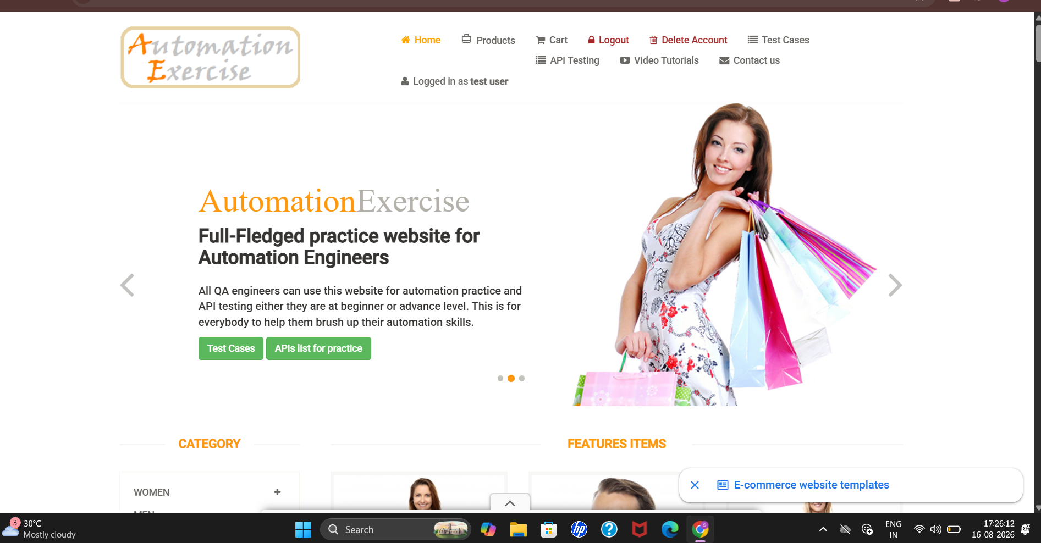

TC06 – Verify Logout Functionality
Test Case: Verify that the user can logout successfully.
Test Data: Logged-in user
Steps:
Open the Automation Exercise website.
- Click on the Signup / Login option.
- Log in using valid email address and password.
- Verify that the user is logged in successfully.
- Click on the Logout option.
- Verify that the user is logged out successfully.
- Verify that the Login page is displayed again.
Expected Result: User should be logged out successfully and the login page should be accessible.
Actual Result: User logged out successfully and the login page was displayed.
Status: PASS
Screenshot:

